Club Ethos and Coaching Philosophy

Published October 2016

Billingshurst FC

Contents
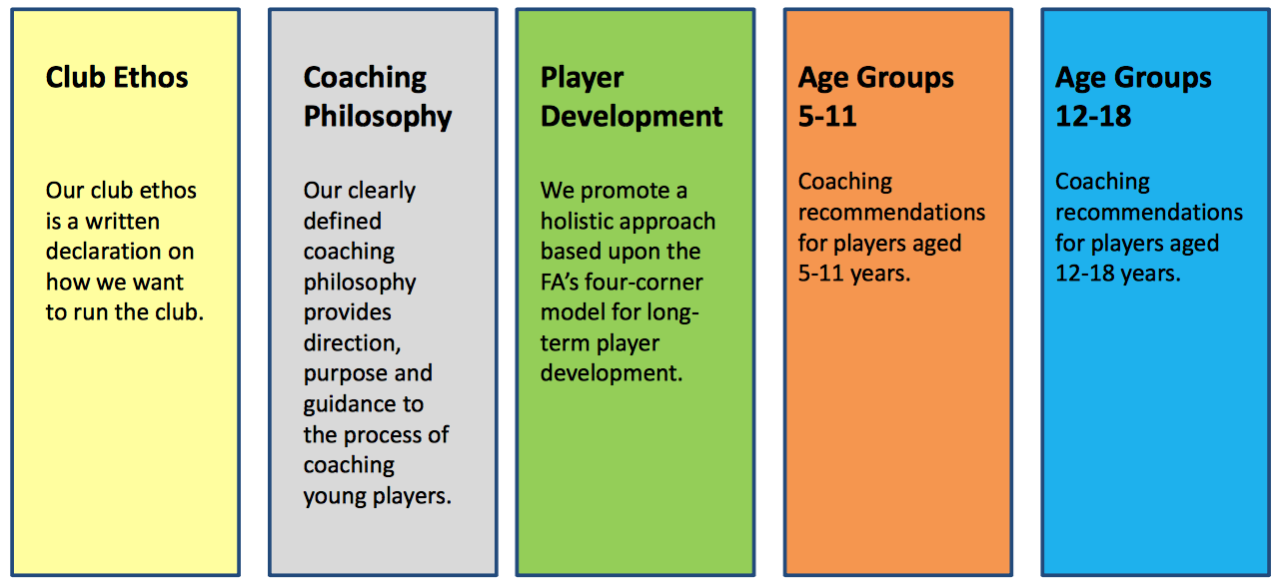

Club Ethos
Our club ethos is a written declaration that sets out how we want to run as a club. It’s simple and concise and can be understood by players, parents and officials
BFC Club Ethos
- To provide football to children of all ages and abilities, in a safe, friendly and enjoyable environment.
- To deliver age-appropriate coaching to support long-term player development.
- To offer a challenging but supportive environment where children can learn from their mistakes without undue pressure or anxiety.
- To encourage all players to try their best and make the most of their abilities. Core values of hard work, honesty, togetherness and striving to be the best to be demonstrated at all times.
- To promote good behaviour and respect for others through our Team Officials (Coaches)/Player/Spectator Codes of Conduct.
- We see football as a team game and encourage this as a priority.
- We do not support winning at all costs.

Coaching Philosophy
Our clearly defined coaching philosophy provides direction, purpose and guidance to the process of coaching young players.

Coaching Aims
- Make the game safe, fair and enjoyable.
- Provide age-appropriate coaching (5-11, 12-16, 17+).
- Develop the whole player across all four corners of the Football Association’s LTPD model.
  - – Improve the player’s movement skills: agility, balance, coordination and speed (ABCs).
  - – Develop the player’s technical skills.
  - – Increase the player’s decision-making capabilities.
  - – Teach the player life skills (co-operation, teamwork, communication and friendship).

Role of the Coach
• Mentor – Listen to players, give advice and extend their thinking.
• Motivator – Set appropriate challenges to inspire the players.
• Friend – Make the environment welcoming and inclusive.
• Facilitator – Allow players to enjoy playing the game.

A Good Coach ...
- Encourages players to try new skills.
- Enthuses and motivates players.
- Supports and inspires regular practice.
- Encourages children to be the best they can be.
- Prioritises the unique individuality of the child.
- Puts the child’s needs at the centre of the activity.

A Good Coach Also ...
- Understands issues that impact upon young player development.
- Considers how children learn as well as issues of self-esteem and motivation,
- Communicates using age-appropriate language and instructions.
- Understands children are not mini-adults and that developing football players is a long term process.
- Fosters a life-long love of the game.

Coaching Qualifications
• As a minimum, all coaches at our club will undergo the following training courses: – The FA Level 1 Award in Coaching Football – FA Emergency Aid
– FA Safeguarding Children Workshop
• All our coaches have Enhanced CRC checks.
– The FA requires everyone who works or volunteers in children’s football and regularly cares for, trains, supervises or is in sole charge of children to apply for a FA CRC Enhanced Disclosure

Coaches’ Behaviour
- Coaches are required to strictly follow the Respect Code of Conduct.
- Players must be free to play during matches, with positive encouragement from parents and coaches.
- Information from the touchline should be in the form of occasional questions from the coaching staff.
- Patrolling the touchline giving continuous shouted instructions must not happen.
- Players always try their best and will learn from their mistakes without being told what they have done wrong.

Player Development
A holistic approach based upon the FA’s four-corner model for long- term player development: Technical, Physical, Social and Psychological.

The FA Four-Corner Model

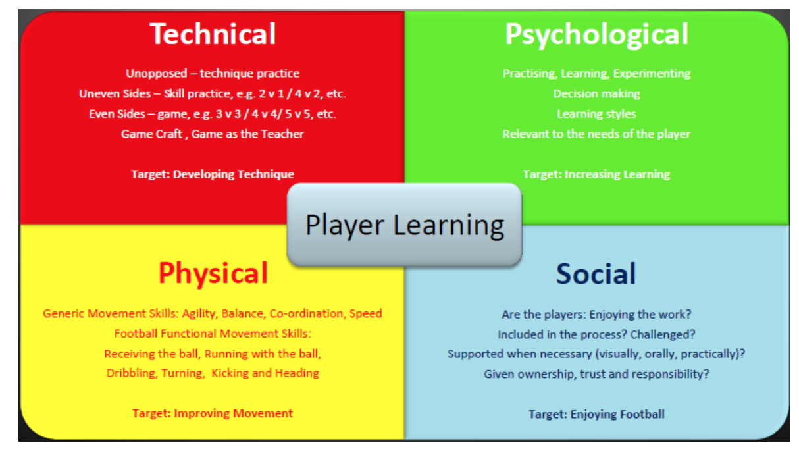

Technical
- Encourage players to try new skills in practice and work out where they can be used in a game.
- Where appropriate, practice should replicate the demands of the game, encouraging players to think and make decisions just as they would do in a match.
- Vary the difficulty to match the needs of the individual, by altering the Space, Task, Equipment or Players (STEP).
- Cut down on the ‘stop, stand still’ phrase and let players’ experience the flow of the game and practice.

Physical
- Appropriate movement skills which develop agility, balance, co-ordination and speed should be encouraged through enjoyable games such as tag.
- Through well designed practice, all coaching activities can include physical outcomes.
- Remember players grow at different rates and may need support and patience as they develop.
- Children are not mini-adults and shouldn’t be subjected to laps of the pitch or press-ups.
- All ‘warm ups’ should be dynamic not static.

Psychological
- Use different methods of communication to engage with different types of learners.
- Visual (seeing): Tactics boards, posters, diagrams, cue and prompt cards, as well as cones on pitch.
- Auditory (hearing): Speak with players, ask questions, encourage discussions in groups amongst the players to solve game-related problems.
- Kinaesthetic (doing): Demonstration to the team by the coach or by a player to their team-mates.

Social
- Be a good role model for the players.
- Create a positive and welcoming environment.
- Praise players for their effort and endeavour as well as their ability.
- Manage mistakes to the player’s advantage – understand what they were trying to do. Sometimes they will have the right idea but just fail in the execution of the technique or the skill.
- Make sure football is fun, but with a purpose. Ensure the development of skills and game understanding.

Ability and Opinion
• A player’s performance in practice and matches can be influenced by the following factors, all of which need to be considered when forming an opinion of a player’s true ability;
– Date of Birth, Body Type, Adolescent Growth Spurt, Physical Maturity, Psychological Maturity, Social Maturity, Previous Experience, Opposition, Own Team’s Playing Standards, Position Suitability, The Instructions Given to the Player, Recent Playing Activity.

Growth and Maturation
- Appreciate that all players are growing and maturing at different rates.
- Be patient, supportive and encouraging with ALL the players in your squad.
- Understand that all some players need is ‘time’.
- Don’t mistake levels of physical maturity for maturity in other areas.
- Don’t assume that the current success of a player is an indicator of on-going proficiency.
- Don’t over-burden the players that represent the extreme or late developer.

Relative Age Effect
- Recruitment trends in professional academies show a bias towards players born between Sept-Dec, making them the older players in their age group.
- Design and deliver challenges which offset the relative age effect;
  - – Consider changing the pitch size, the size of the ball, rules of the practice/game, the game format.
  - – Consider grouping bigger and physically developed players to compete against each other in practice.

Minimising Distractions
- By planning ahead the coach can create an environment that minimises distractions and helps players to stay ‘on-task’ for longer.
- Organise sessions that are interesting, challenging, varied and fun.
- Avoid players standing in line or asking them to wait around for too long without a focus.
- Plan arrival activities so players can begin practising as soon as they arrive.

Managing Behaviour
- Outline rights and responsibilities to players. Refer to FA Respect Codes of Conduct.
- Praise and reward good behaviour.
- If you have to intervene, do so in a calm and controlled manner.
- If boundaries are consistently broken then there should be a consequence.
- As a coach, remember the only person’s behaviour you can control is your own, so set a good example.

Formats of the Game
• Young players should be exposed to a variety of games they can actually play rather than struggling to understand a game created for adults.

Revised Formats of the Game

￼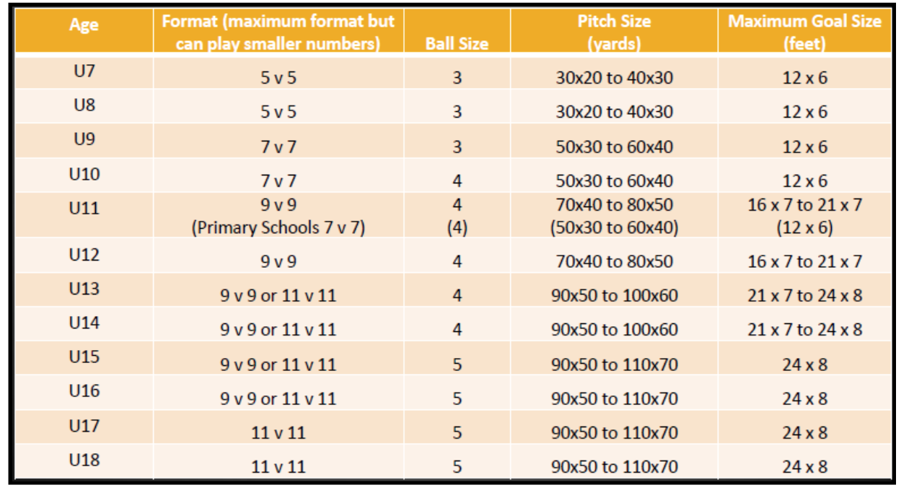

Coaching Recommendations for Players Aged 5-11
Creating a positive and enjoyable learning environment, which prioritises skills development, decision-making, fundamental movement skills and experimentation is crucial for young players in this age-group who are learning how to play.

Positive Learning Environment
- Encourage players to be creative and take considered risks in both practice and games.
- Remember – mistakes do happen.
- Let players make some of the decisions.
- Let them know that their opinions count too.
- Create opportunities for players to explore, question and foster their natural curiosity and imagination.
- Allow all players to experience success.

Let the Players Play
- All children should be given a minimum playing time of 50% total game time on match-days.
- Help players develop their game-understanding by rotating positions during practice and games.
- Ensure players are given the chance to play a ‘game’ during every practice session.
- Don’t let the children’s arena become dominated by adults.

Skill Development and Decision making
- Practice should replicate the demands of the ‘game’ as much as possible. Give lots of opportunities to practice different aspects of the game (shooting, dribbling, tackling, passing, goalkeeping), in context.
- Goals should be used in practice as often as possible to help players’ enjoyment and motivation.
- Small-sided games on appropriate sized pitches provide young players with opposition, decision-making and challenge, all of which help their skills development.

Themed Practice
• Try and link the different parts of a coaching practice together. For example:
– Warm-up: Players work in twos passing through a variety of different sized gates, using different techniques and surfaces of the foot.
– Skill development: Play a small-sided possession game (.e.g. 3v1 or 4v2) on appropriate sized pitch, don’t make the pitch too large.
– Game: Any 4v4 game with a focus on passing or a through-the-thirds game.

Appropriate Challenges
- Set challenges in practice sessions, e.g. Use your weaker foot if you can.
- Reinforce the learning focus from practice sessions on match day.
- Set players specific challenges that link to the theme of a recent practice session, which can be discussed at half-time and after the game.
- During practice sessions try to ‘match’ players up in lots of different ways in order to meet their individual needs.

Develop Fundamental Movement Skills
- Between the ages of 5-11 players have a ‘window of opportunity’ to develop their agility, balance, co-ordination and speed (ABCs).
- Coaches should be creative in their practice design and build in a physical benefit for the players, e.g.
  - – Tag Games
  - – Running and Dodging
  - – Throwing and Catching
  - – Jumping and Balancing

Coaching Methods ‘5 Pillars’

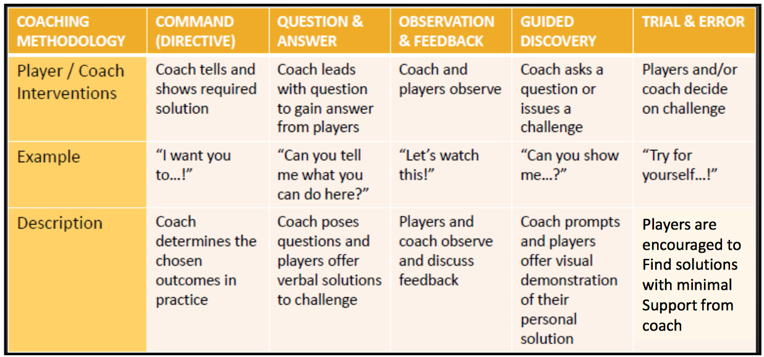

Use Small-Sided Games
- Players should experience a variety of formats of the game, played on appropriately sized pitches.
- The game is essentially a series of different scenarios (1v1, 2v1, 1v2, 3v2 etc.) and players should experience a variety of these game-like challenges during practice sessions.
- Coaches should use uneven sides in practice to challenge the players.

Appreciate What it’s Like to Be Young
- What the game of football ‘looks’ like for a group of 7 and 8 year olds will be significantly different to the game played by older players and adults.
- If a coach tries to ‘fast forward’ young players to this level too quickly, important stages of development may be missed.
- Young players shouldn’t be benchmarked against adult professional players.

Consider Young Players’ Self-esteem
- Coaches should consider how their decisions will impact upon a young player’s self-esteem, motivation and enjoyment of the game.
- For example, what would it feel like to be repeatedly used as a substitute?
- Coaches should praise effort and positive behaviour as well as good play.

Things to Avoid
- Don’t impose unrealistic adult expectations on young players.
- Don’t be so intent on winning games that young players miss out on the opportunities to learn and fall in love with the game.
- Don’t apply ‘out-dated’ coaching methods with young players.
- Avoid children standing in lines or queuing.

Coaching Recommendations for Players Aged 12-18
Coaches should continue to prioritise a positive learning environment (as recommended in the 5-11 section), ensuring methods and content are made appropriate to the age and ability of the players in this age-range.

Ensure Practices are Relevant and Realistic
- Realistic passing, receiving and possession practices which create appropriate pressure, interference and distraction will help young players develop their awareness and game understanding.
- Become more effective ‘off the ball’. Develop an understanding of movement to support team-mates and how to create and exploit space.
- Develop scanning, predicting and assessing skills to form a ‘picture’ before receiving the ball.

Develop Basic Tactical Understanding
• Introduce players to the 6 phases of the game:
- – Attacking when opponents are ‘in balance’
- – Attacking when opponents are ‘out of balance’
- – Defensive play whilst ‘in balance’
- – Defensive play whilst ‘out of balance’
- – The finishing phase
- – Goalkeeping

Develop Understanding of Four Key Moments
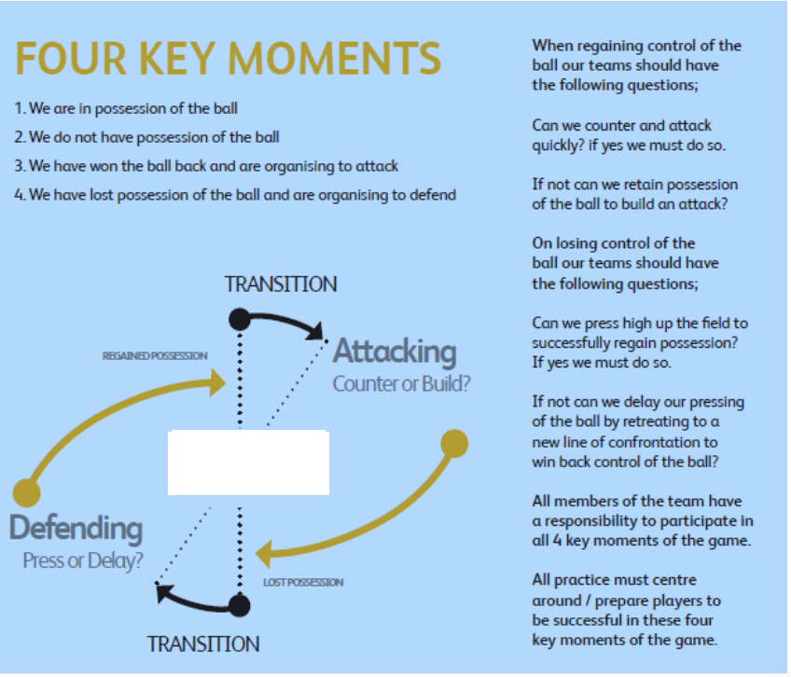

Introduce Some Position Specific Practices
- As players get older they will begin to recognise the significance of practice sessions to their role within the team.
- Some specific positional practices should be introduced as appropriate.
- This should be balanced with experience playing and practicing in different positions.

Encourage players to be Self- Reflective
- Players should be encouraged to reflect on their effectiveness in practice in games, and challenged to think about how they may improve next time.
- This process may be done individually, in small groups or collectively.
- It may be enhanced if the team/player and the coach discuss realistic and achievable challenges and goals to work towards.

Encourage Creativity
- Coaches should continue to encourage players in this age group to be creative by designing challenging practice sessions.
- Master the skill of posing effective questions to develop the players’ active involvement in the training and learning process,
- Encourage players to think, examine, judge and evaluate to find their own solutions.

